Step 1 – Find the Manual Install options
- Continue through the normal enrollment process until you reach the download screen.  - Select “Show all operating systems”. | 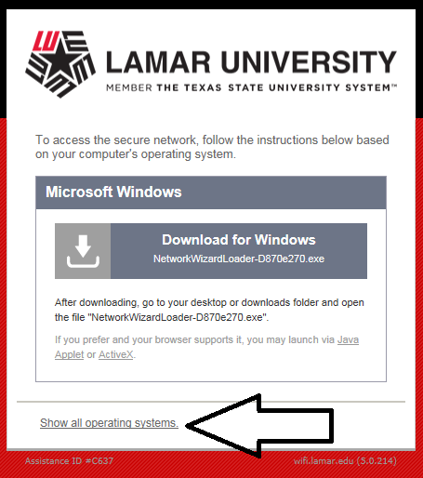
- Expand “Other Operating Systems”. | 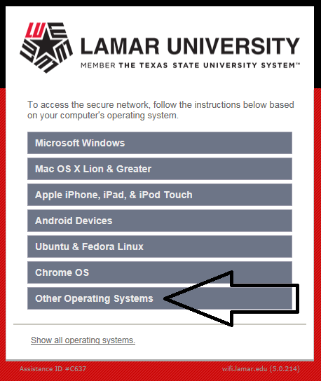
- You should see 3 steps on the screen. | 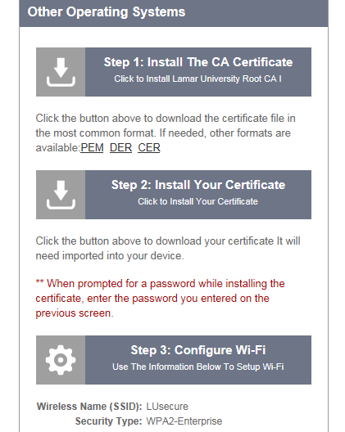

Step 2 – Install the CA Certificate
- Select “Step 1: Install The CA Certificate”. | 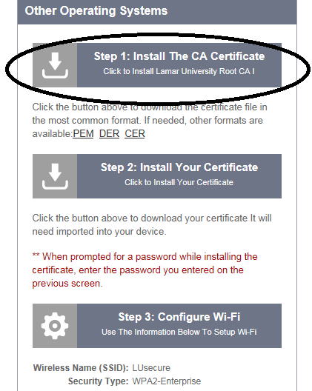
- When the download prompts you, select “Open”.  - On the windows box, select “Install Certificate”.  - On the Certificate Import Wizard, select “Next”.  - Verify “Automatically select the certificate store…” is selected, then choose “Next”.  - Select “Finish” The following message will display: “The Import was successfully” Click “Okay” twice to close both screen. | 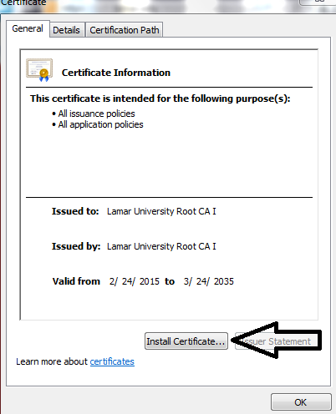
Step 3 – Install Your Device Certificate
- Return to your web browser.  - Select “Step 2: Install Your Certificates”.  - When the download prompts you, select “Open”.  - On the windows box, select “Install Certificate”.  - On the Certificate Import Wizard, select “Next” twice.  - When asked for the password, enter your Lamar LEA password and ensure only the last box below is checked.  - Verify “Automatically select the certificate store…” is selected, then choose “Next”.  - Select “Finish.” The follow message will display: “The import was successful” Click “Okay” twice to close both screen. | 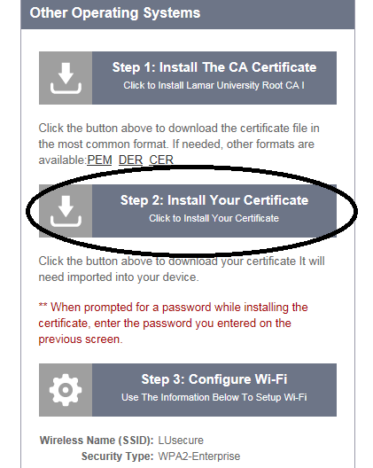  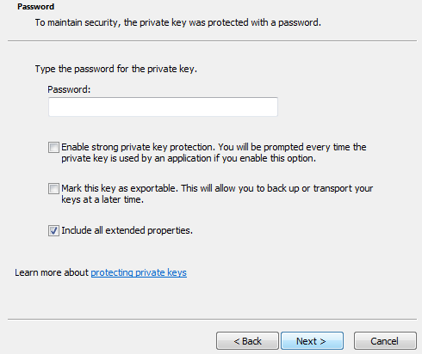
Step 4 - Connecting to LUsecure
- Go to your wifi settings and connect to the LUsecure network.
* If you are asked for a username and password, enter the local admin account username and password on the laptop.
* If presented with a warning about the certificate asking if you want to terminate, select “Connect”.

- Verify connectivity by visiting www.lamar.edu .

